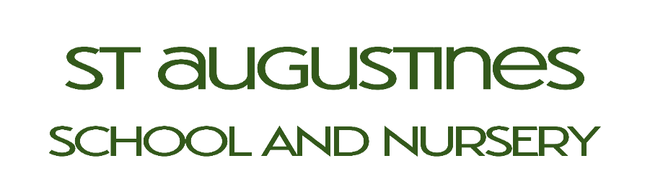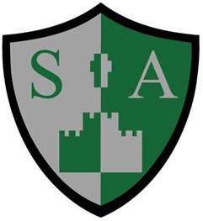
St Augustine’s Catholic Primary School Local Governing Board Register 2022/23
Governors Name | Category of Governor | Positions of responsibility held | Body appointed by | Term of office and expiry date | Committees served on | Pecuniary/conflict of interest registered
Antoinette Woodhead | Foundation Governor | Chair of Governors  Chair of all committees served on  Linked Governor for Maths and Class 3 | Diocese of Shrewsbury | 4 years  (01/04/27) | - Headteacher’s performance Management  - Pupil & Staff appeals  - Appointments and Disclosures  - Exclusions and complaints | Foundation Governor at St Mary’s church of England school, Runcorn
Nedra Sothern | Headteacher |  | Holy Family Catholic MAT | Whilst in post | Affiliated to all committees by virtue of the position | Employed by the school
Christine Smith | Foundation Governor | Vice Chair of Governors  Linked Governor for English, Foundations Stage Two, Class 4 | Diocese of Shrewsbury | 4 years  (01/04/27) | - Headteacher Performance Management  - Appointments and Disclosures | None registered
Rob Hughes | Foundation Governor |  | Diocese of Shrewsbury | 4 years  (01/04/27) |  | Employed by the Diocese
Claire Barker | Staff Governor |  | Elected | 4 Years  (09/04/27) |  | Employed by the school.
Kelly Dowling | Parent Governor |  | Elected | 4 years  (01/04/27) |  | None registered
Michelle Lewis | Parent Governor |  | Elected | 4 years  (01/04/27) |  | None registered

Governors Name | Category of Governor | Positions of responsibility held | Body appointed by | Term of office and expiry date | - Committees served on | Pecuniary/conflict of interest registered
Jaina Chwastek | Foundation Governor | Linked Governor for Class 2  Safeguarding | Diocese of Shrewsbury | Resigned March 2023 | - Headteacher Performance Management  - Appeals | None registered
Jess Ellams & P Johnson Currently on Maternity Leave | Staff |  | Elected | 4 years |  | Employed by the school

Please Note:
All Governors terms of office are for a 4 year period unless otherwise indicated.
Additional committees are convened as required for example: pay appeals.
From the 1st September 2020 the full governing board meetings were restructured to half termly.
Term of offices were renewed following the transfer to the Holy Family Catholic MAT.

