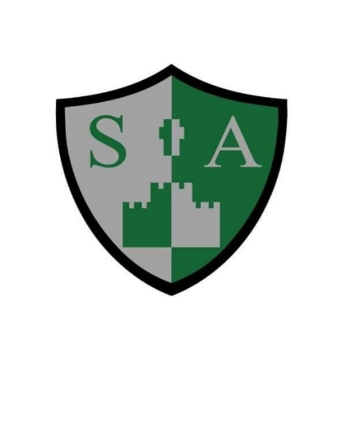

St Augustine’s Catholic Primary School and Nursery

**Phonics Policy**

At St Augustine’s we use Read, Write Inc. Phonics. RWI is an inclusive literacy programme for all children learning to read. It teaches synthetic phonics. Children learn the 44 common sounds in the English language and how to blend them to read and spell. At St Augustine’s we understand that reading is the key that unlocks the whole curriculum so the ability to efficiently decode is essential. RWI lessons occur each morning with no exceptions, as the continuity and pace of the programme is key to accelerating the progress of children’s reading development. Staff also recap and review sounds throughout the day with an additional speed sound lesson occurring in each class during the afternoon session.

**Aims and objectives of the RWI programme**

To teach children to:

* Apply the skill of blending phonemes in order to read words.
* Segment words into their constituent phonemes in order to spell words.
* Learn that blending and segmenting words are reversible processes.
* Read high frequency words that do not conform to regular phonic patterns.
* Read words and texts that are within their phonic capabilities as soon as possible.
* Decode texts effortlessly so all children’s resources can be used to comprehend what they are reading.
* Spell effortlessly so all children’s resources can be directed towards their writing.

**Teaching and Learning Styles**

**Praise-** We understand that children learn quickly in a positive climate.

**Pace-** This is essential to a good quality phonics lesson.

**Purpose-** Every part of the lesson has a specific purpose.

**Passion-** RWI is a prescriptive programme. It is the enthusiasm, energy and passion that our teachers put into the lessons which bring the programme to life. We value active learning; our phonics lessons are fun, engaging and dynamic.

**Participation-** A strong feature of RWI lessons is the collaborative nature of the sessions. Children work in partners and ‘teach each other’ (based on research which states that we learn 70% of what we talk about with our partner and 90% of what we teach).

**R.W.I across the school**

**Nursery-** Children entering our nursery take part in daily phase one activities. This includes; environmental sounds, instrumental sounds, body percussion and rhythm and rhyme. Once children are secure in phase one, initial sounds are introduced following the RWI sequence of set 1 sounds. Staff use ‘Fred Talk’ daily with our nursery children with the expectation that children will begin to encode sounds to orally blend. Our nursery staff utilise phonics flashcards, initial sound picture cards and a Fred the Frog toy.

**Reception & Key Stage One-** Due to children’s strong start at our school nursery, children are ready to start set 1 RWI phonics straight away with no time wasted. Phonics lessons occur daily between 9:15-9:45am. Within this time a speed sound lesson is taught which is followed up by a handwriting and spelling session. At St Augustine’s we follow the ‘keep up not catch up’ approach. Children are taught in whole class year groups and high quality interventions are planned for by the reading lead for children who are at risk of falling behind. The impact of interventions on children’s progress is reviewed by the reading lead half termly. Children take the statutory phonics screening check in year one. If children do not pass this statutory check, then they continue to have daily phonics with the view of passing the check when re-assessed in year two.

**Key Stage Two-** Groups of children in key stage two are also taught RWI on a daily basis if it is thought that they would benefit from the programme. This includes children who did not pass the phonics screening check in key stage one, children with additional needs or children who have joined our school where English is an additional language.

As a whole school, we use **‘Fred Fingers’** to support children’s ability to segment words into their constituent phonemes in order to spell accurately.

**Progression throughout the scheme**

* **RWI phonics-** For children in nursery, reception and key stage one. Some children in key stage two may also receive RWI phonics if it is thought to be necessary for their progress.
* **Get Spelling-** This is for children in year 2 who can read accurately and with increasing speed. Teachers use ‘Get Spelling’ for 15 minutes a day. The teaching of phoneme-grapheme correspondence underpins ‘Get Spell,’ it also develops children’s knowledge of word families, how suffixes impact upon root words, and provides mnemonics to remember the trickiest spellings.

**Assessment**

Children are assessed informally throughout every lesson. This is based on how children read the grapheme cards and their ability to read words containing the taught grapheme (green word cards). Children are also assessed on their ability to instantly recognise ‘tricky words’ from the red word lists.

Children are formally assessed each half term using an assessment pro forma provided by the phonics lead. Phonics assessments test children’s fluency, accuracy and comprehension as we want our children to develop into efficient readers. The phonics lead oversees and monitors assessments half termly in order for any gaps in children’s learning to be addressed. The phonics lead feeds back to phonics teachers and teaching assistants in order to plan next steps in children’s learning.

Children joining our school from other settings are assessed swiftly using our R.W.I phonics assessment. This provides the class teacher and phonics lead with a clear starting point for that child and ensures any interventions which may be needed are planned for and put into place as a matter of urgency.

**Phonic Interventions**

Half termly assessments highlight to teachers and the reading lead any children who are at risk of falling behind. These children continue to receive whole class phonics as we firmly take the stance on a ‘keep up not catch up’ approach. However, these children will attend an intervention with either their class teacher or a teaching assistant. This intervention could take place in a small group or on a one to one level (depending on outcomes of half termly assessments). The one to one phonics kit is used by teachers and teaching assistants to support children in making rapid progress in order to close the gap between them and their peers. The impact of interventions is monitored by the reading lead on a half termly basis to ensure children are making sufficient progress.

**Monitoring and Review**

The phonics lead:

* Oversees assessment of all children receiving RWI in school in order for children’s learning to be pitched at an appropriate level.
* ‘Drops in’ on R.W.I groups to give advice on the teaching of phonics in each key stage.
* Where necessary, models lessons to staff.
* Attends up to date meetings when they occur and reports back to staff who teach phonics.
* Speaks to the head teacher regarding professional development for staff, teaching spaces and other pertinent matters, such as, impact of interventions.