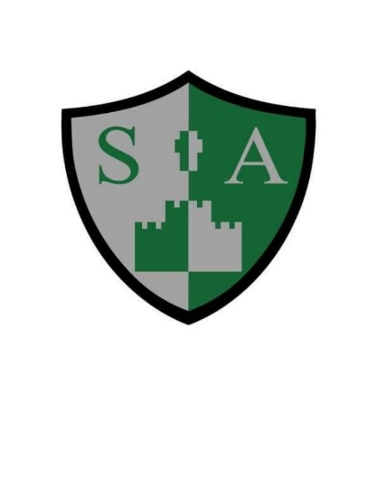

St Augustine’s Catholic Primary School and Nursery

**Writing Policy**

Writing at St Augustine’s is taught and praised in a range of ways. It is taught daily across the school to ensure continuity and rigour in teaching and learning of knowledge and skills and is taught through a range of subjects. We aim, wherever possible, to create cross-curricular writing opportunities, as we believe that in order for children to see themselves as successful writers they need to be involved in writing for a purpose. We create ‘hooks’ for our children to full immerse themselves in and capture the roles in the high quality texts. We follow the National Curriculum (2014) which ensures that a range of genres are covered, including narrative (e.g. extended stories, stories by the same author, myths and legends, adventure stories and traditional stories), non-fiction (e.g. persuasive texts, non-chronological reports, information texts, recounts, reports and letters) and poetry (e.g. rhyme, nonsense rhymes, shape poems, acrostic and descriptive poetry). Genres are taught and learnt considering the purpose, form and audience.

Throughout each unit, the links between reading and writing are made explicit – we read as writers and we write as readers. The progress throughout each unit of work shows the transition between reading as writers (focusing on structure, characterisation, and language features etc…) to writing as readers (word play, describing, composition, planning, editing, revising etc…). Integral to the process of writing is speaking and listening. ‘Talk for writing’ is essential to enable children to articulate their thoughts, retell stories, orally create new stories and orally rehearse what they are going to write and re-read what they have written. This underlines and runs alongside the writing process.

**The Teaching and Learning of Writing**

In the early years emergent writing is encouraged through the use of different writing materials, including felt tipped pens, crayons, chalk, sand, magnetic letters, big brushes, water, paint and computers, as well as writing in the role-play areas, such as postcards, menus, invitations, labels etc… Alongside this, children take part in activities to encourage and develop gross and fine motor skills necessary to write in a legible script. Daily phonics lessons build their phonic and spelling knowledge to enable them to sound out words and spell high frequency words correctly.

As children progress throughout the school, they are given many opportunities to write independently and to apply the skills they have learnt and practised in shared and guided writing. Wherever possible, writing is made meaningful by being planned for a specific purpose or in response to a particular experience which creates a hook for the children. Extended writing opportunities take place across the curriculum in science, knowledge and RE. This provides children with the opportunity to demonstrate their literacy knowledge and skills, showing depth and mastery and allows them to write about a familiar topic without explicit literacy success criteria guidance.

We recognise that spoken language underpins the development of reading and writing. The quality and variety of language that pupils hear and speak are vital for developing their vocabulary and grammar and their understanding for reading and writing. Teachers ensure the continual development of pupils’ confidence and competence in their knowledge of spoken language and listening skills. They are assisted in making their thinking clear to themselves as well as to others and teachers ensure that pupils build secure foundations by using discussion to probe and remedy any misconceptions. Building on this foundation, we teach literacy using a range of strategies which include:

**Modelling Writing** - The teacher talks aloud the thought processes as a writer. They model strategies in front of the children, communicating the strategies being used. Teachers may model writing skills such as punctuation, rehearsal, proof reading, editing, word selection, sentence construction and paragraphing.

**Shared Writing** - This is a collaborative approach in which the pupils contribute their ideas and thoughts for the teacher to write. The teacher models and teaches specific writing skills and there is the opportunity for discussion to choose the most effective or suitable ideas.

**Guided Writing** - Pupils are grouped by writing ability. The teacher or other adult works with the group on a carefully selected task appropriate to that group’s needs and targets. This will focus on a particular aspect of the writing process rather than writing a complete piece.

**Independent Writing** - Children are given opportunities to apply their understanding of the text type in their own writing. They are encouraged to plan, draft, write, edit and assess their work, applying the skills they have learnt throughout the unit of work on that particular genre.

All English lessons have clear success criteria so that the children understand the expectations of the task and how they can achieve their best in the lesson. Success criteria are consistently referred to during teacher modelling and used effectively for self and peer assessment at the end of a task. The success criteria are clearly referred to when feedback from the teacher is given, either verbally or in writing. English activities are effectively differentiated so that all children can achieve the success criteria and feel empowered by their own accomplishment. Nevertheless, all children are given the chance to reach the same high level in every lesson. Effective differentiation is in place so that all children have the opportunity to meet every learning intention through having vocabulary word banks, writing frames and sentence starters, mixed ability groupings and adult support.

Vocabulary, grammar and punctuation is planned and taught as an integral part of each unit of work. The objectives are carefully matched to the unit of work to enable them to be taught and learnt within a meaningful context. Each year group is provided with an English Overview for that year which gives detailed information about the genres and statutory requirements that each year group should be following. The overviews show progression with genres across the year groups. Teachers will use the overviews to plan daily Literacy lessons that are differentiated and tailored to individual classes needs.

**Assessment**

Children are assessed formatively through thorough questioning and marking to ensure that teachers understand where children are currently in their learning and what their next steps need to be. This helps to ensure that maximum progress is made throughout writing across the school. In addition to this, regularly timetabled summative assessment opportunities are planned into the academic year to ensure that the progress in knowledge and skills that each child makes is accurately measured. Summative assessment opportunities are used to support teachers in their assessment judgements and should not replace teacher judgement based on experience of the child in everyday lessons.

As well as ongoing formative assessment, teachers from Reception to Year 6 assess the writing of every child half termly. A piece of writing from each child will be assessed according to the criteria for the age expectation at six points throughout the year by the class teacher, taking into account achievement from the previous term. Teachers also take into account work completed throughout the term.

**Grammar and Punctuation**

There is a strong focus on SPaG (Spelling, Punctuation and Grammar) within the curriculum. Teachers will therefore give this the necessary time and attention regularly each week. SPaG is taught throughout lessons and the skills are then embedded throughout the curriculum. SPaG objectives for each year group are included in the English overviews. At the end of KS1 and KS2, the children will take their SATs which will include a SPaG test. Children in Years 3-5 will take optional NFER SPaG tests.

**Handwriting - See Handwriting Policy**

This is a key area of focus embedded within the curriculum, which has specific statutory teaching requirements for each year group. Handwriting is a means of expressing language. It is a physical way of expressing thoughts and ideas and a means of communicating with others.

Neat cursive writing is promoted throughout the school. Teachers and Teaching Assistants set high standards for handwriting and presentation at all times. In EYFS and Key Stage 1 the focus is for legible, neat letters that are formed on the line. The journey to neat cursive handwriting starts in Key Stage 2 where the focus develops to joining letters. This is then practised and developed through every year group.

This policy will be updated annually.